International Commercial Arbitration Summer Seminar

Presented by
The University of Florence &
The ICC International Court of Arbitration

July 22-26, 2013

Florence, Italy

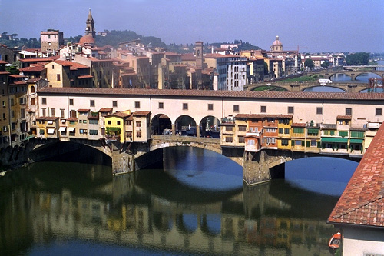

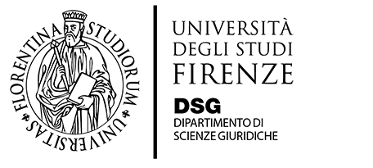
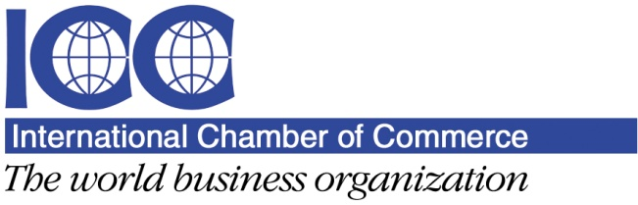

International Commercial Arbitration Summer Seminar
Monday July 22, 2013

9:00 a.m.

Registration and Continental Breakfast

10:00 -10:30 a.m.
Welcome & Introduction

10:30 - 11:30 a.m.
Introduction to International Commercial Arbitration

• Introduction to international commercial arbitration
• Why choose arbitration over litigation
• Ad hoc vs. institutional
• United Nations Convention
• Important terminology

This session will introduce international arbitration as a dispute resolution process and distinguish it from court litigation. We will also compare and contrast the types of international arbitration, such as ad hoc and institutional arbitration. We will conclude by explaining the primary method of enforcing commercial arbitration awards through the 1958 United Nations Convention on the Recognition and Enforcement of Foreign Arbitral Awards (the “New York Convention”).

11:30 a.m. - 12:00 p.m.

Coffee Break

12:00 - 1:00 p.m.

Introduction to International Commercial Arbitration (continued)

1:00 - 3:00 p.m.
Lunch Break

3:00 - 4:00 p.m.
International Arbitration Doctrines
• International arbitration agreements
• Separability doctrine
• Competence-competence
• Validity and non-arbitrability

This session will address threshold issues that arise when determining the enforceability and interpretation of an arbitration clause. We will explain why the validity of the arbitration agreement is a separate determination from the validity of the underlying substantive contract and why the arbitral tribunal has the power to determine its own jurisdiction. We will also address issues involving the intersection of international and domestic law, such as determining the validity of the arbitration agreement itself and determining whether a specific subject matter or claim may or may not be arbitrated.

4:00 - 4:15 p.m.

Coffee Break

4:15 - 5:30 p.m.

International Arbitration Doctrines (continued)

Tuesday July 23, 2013

10:00 - 11:30 a.m.
The Parties’ Choice
• Overview
• Arbitral seat
• Applicable law
• Language
• Arbitrator qualifications
• Number of arbitrators
• Choice of arbitration rules/institution

This session will address the quintessential freedom of choice that parties have to determine what shape their arbitral process will take. In addition to choosing their arbitrators, parties are free to determine the location, language, number of arbitrators and applicable law for their arbitration, as well as many other parameters. This freedom of choice is one of the most attractive features of international arbitration.

11:30 a.m. - 12:00 p.m.

Coffee Break

Program

International Commercial Arbitration Summer Seminar
Tuesday July 23, 2013 (cont.)

12:00 - 1:00 p.m.
The Agreement to Arbitrate
• Types of agreements
• Indispensable elements
• Generally recommended elements
• Pathological elements

This session will dissect the wording of the arbitration agreement and examine its various components and elements. We will discuss types of arbitration agreements such as the contractual clause, the “compromis,” the ad hoc arbitration agreement and the institutional arbitration agreement. We will revisit the parties’ choices and examine how those choices are memorialized in writing in the arbitration agreement. We will also examine advanced elements of arbitration clauses, such as multi-staged dispute resolution processes, conflicts of law provisions, amiable compositeur, ex aequo et bono, evidentiary provisions, cost provisions and multi-party provisions. Finally, we will discuss what not to include in an arbitration clause and how pathological elements in arbitration clauses may affect the validity of the agreement or the procedural steps of the arbitration.

1:00 - 3:00 p.m.

Lunch Break

3:00 - 4:30 p.m.

Practical Session on drafting the arbitration agreement based on the ICC Rules, including discussing a handout of pathological clauses

4:30 - 5:00 p.m.

Coffee Break

Wednesday July 24, 2013

10:00 - 11:00 a.m.
The Arbitral Tribunal
• Selection of arbitrators
• Number of arbitrators
• Qualifications
• The arbitrators’ mission
• Scope of arbitrator authority
• Rights and responsibilities
• The appointment process
• Impartiality, independence, availability
• Challenges to arbitrators

This session will address how arbitrators are selected. We will revisit the parties’ choices memorialized in the arbitration clause and examine how those choices are implemented during the arbitrator selection process. We will also examine the mission and authority of an arbitrator in contrast to the purview of a state court judge. We will discuss issues relating to bias, impartiality, independence and availability of arbitrators. We will examine the rights and responsibilities of the arbitrators vis-a-vis the rights and responsibilities of the parties. Finally, we will discuss how and why an arbitrator may be challenged and ultimately removed from the arbitral tribunal.

11:00 - 11:30 a.m.

Coffee Break

11:30 a.m. - 1:00 p.m.

The Arbitral Tribunal (continued)

1:00 - 3:00 p.m.
Lunch Break

3:00 - 4:00 p.m.
Roundtable Discussion with In-House Counsel

During this session, in-house counsel from various corporations will discuss their experience and approach to dispute resolution. In particular, they will provide their views on arbitrator selection and their companies’ particular requirements, if any, for choosing arbitrators.

4:00 - 4:15 p.m.

Coffee Break

4:15 - 5:00 p.m.

Roundtable Discussion (continued)

Program

International Commercial Arbitration Summer Seminar
Thursday July 25, 2013 (cont.)

10:00 - 11:00 a.m.
Conducting the Arbitration

• The request
• Terms of reference
• Hearing and evidence
• Discovery
• Experts
• Conservatory and interim measures
• Costs

This session will address how parties commence an arbitration and how the arbitral procedure is conducted. We will discuss the ICC arbitration process step-by-step, including the Request for Arbitration, the Terms of Reference, cost calculations, the hearings and the presentation of evidence. We will also address party requests for conservatory or interim measures.

11:00 - 11:30 a.m.

Coffee Break

11:30 - 1:00 p.m.

Conducting the Arbitrations (continued)

1:00 - 3:00 p.m.

Lunch Break

3:00 - 4:00 p.m.
Practical Session on Cross-Examination

• Comparative approach: EU vs. US
• Techniques
• Comparison to litigation

This session will delve deeper into the presentation of evidence. We will compare and contrast how various legal traditions handle questioning witnesses, with a particular emphasis on comparing and contrasting the practices of the European Union and the United States. During this session, we will present a brief mock cross-examination of a witness.

4:00 - 4:15 p.m.

Coffee Break

4:15 - 5:00 p.m.

Practical Session on Cross-Examination (continued)

Friday July 26, 2013

9:30 - 11:00 a.m.
The Arbitral Award
• Need for reasoning in the award
• Scrutiny of the award
• Recognition and enforcement
• Setting aside an award
• UN Convention and the public policy exception
• Review and standards of review

This session will address the final stages of an arbitration, including the rendering of the arbitral award and enforcement procedures. The ICC requires that arbitrators state reasons for their decisions. In addition, the ICC reviews each and every arbitration award during its scrutiny process to ensure consistency, quality and thoroughness. After the award has been issued, the parties will seek recognition and enforcement of the award. What are the parties’ options for enforcing or for setting aside or blocking the enforcement of the award? We will look to the New York Convention for answers and explain the standards of review that a domestic court may or may not use when determining whether to grant or deny the recognition and enforcement of an international arbitration award.

11:00 - 11:30 a.m.

Coffee Break

11:30 a.m. - 1:00 p.m.

The Arbitral Award (continued)

1:00 p.m.

Closing of Seminar; Final Remarks

Program

International Commercial Arbitration Summer Seminar
- Guido Alpa, Professor of Civil Law, University “La Sapienza” of Rome; President, Italian Bar Council
- Mark Beckett, Partner, Chadbourne & Parke LLP; Lecturer, Harvard Law School
- Andrea Carlevaris, Secretary General, International Court of Arbitration
- Giuseppe Conte, Professor of Private Law, University of Florence - School of Law
- Alessandro Curotti, Head of Legal Department, Salvatore Ferragamo S.p.A.
- Maria Beatrice Deli, Professor of Private International Law, University of Molise - Campobasso; Secretary General, Italian Association of Arbitration
- Ferdinando Emanuele, Partner, Cleary Gottlieb Steen & Hamilton LLP
- Pietro Galizzi, Senior Vice President and General Counsel, Saipem S.p.A.
- Francesco Gianni, Founding partner, Gianni Origoni Grippo Cappelli & Partners
- Franco Guariglia, Group Legal & Corporate Affairs Director, Barilla Holding S.p.A.
- Ettore Lombardi, Assistant Professor of Private Law, University of Florence –School of Law
- Paola Lucarelli, Professor of Commercial Law, University of Florence – School of Law
- Fernando Mantilla-Serrano, Partner, Shearman & Sterling LLP; Lecturer, Université de Versailles and Université de Paris XI
- Michael McIlwrath, Associate General Counsel - Litigation, GE Oil & Gas
- Mark Morril, former Deputy General Counsel, Viacom; Independent Arbitrator, MorrilADR
- Angelica Nunez-Anico, Legal Director, Stream/Repsol - Gas Natural
- Luis O'Naghten, Partner, Chair of the International Litigation and Arbitration Group, Akerman Senterfitt; Adjunct Professor, University of Miami Law School and Universidad Panamericana
- Eridania Perez, Partner, Patton Boggs LLP
- Luca Radicati, Partner, Bonelli Erede Pappalardo; Professor of Private International Law, Milan’s Catholic University
- Kenneth Resnick, Vice President & General Counsel, GE Oil & Gas; Professor of International Business Ethics, Syracuse University
- Catherine A. Rogers, Paul and Marjorie Price Faculty Scholar and Professor of Law, The Dickson School of Law, The Pennsylvania State University
- Victoria Shannon, Assistant Professor of Law, Washington & Lee University School of Law; former Deputy Director of the International Court of Arbitration, North America
- Peter Sherwin, Partner, Head of the International Arbitration Group, Proskauer Rose LLP
- Josefa Sicard-Mirabal, Director, Arbitration & ADR, North America, International Court of Arbitration, Adjunt Professor of Law, Fordham University School of Law
- Nancy Thevenin, Special Counsel, Baker & McKenzie LLP
- Federica Tognoni, Legal Counsel, Tesmec Group
- George von Mehren, Partner, Global Chair, International Dispute Resolution, Squire Sanders

Faculty

